

**Dreamweaver e-Project  
GRACIOUS GARMENTS.COM**

**Group Members**

* Taha Naeem
* Dawood Ali
* Syed Ammar Ali
* Fahad Jaweed

**Submitted to:**

‘[eprojects@aptech.ac.in](mailto:eprojects@aptech.ac.in)’

**Project Instructor:**

‘Ms. Rabia Amin’

**Curriculum Code:** 6740





**By Clicking on that button you will reach the**

**appropriate nav-item. This is Site of different garment’s product’s…**

HOME

WOMEN

By clicking on this you will reached the giving product pages, where all product of that brand, supplies are present, …

**MENS**

**BLOG**

**PAGE**

**SHOES**



CATEGORIE’S

WOMEN’S WEAR

MEN’S WEAR

SHOE’S

ACCESSORIE’S

DIFFERENT BRAND’S   
PRODUCT’S



MEN’S WEAR

JACKET

HOODIE’S

DENIM JEAN’S

DESK ORGANIZER

**BRANDS PRODUCTS**

age

SHIRT’S &SSSHIRTS

COAT’S

WOMEN’S WEAR

SHOE’S

SANDLE’S

SNEAKER’S

FORMAL SHOE’S

BOOT’S

FLIP FLOP’S



**HOME PAGE:**

CLICK ON "HOME" PAGE & HOME PAGE WILL BE APPEAR……

.

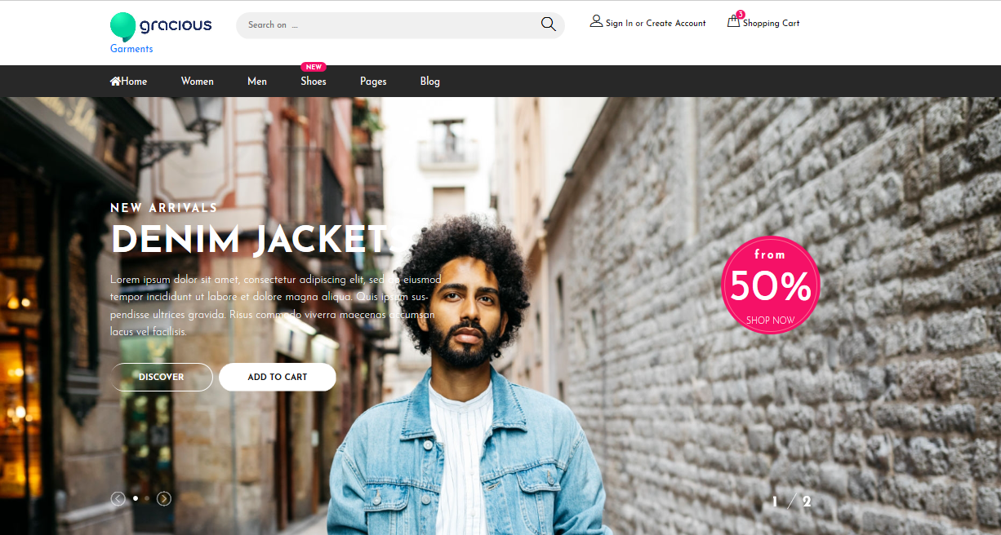



**CONTACT US PAGE:**

CLICK ON "CONTACT US" PAGE & PAGE WILL BE APPEAR……

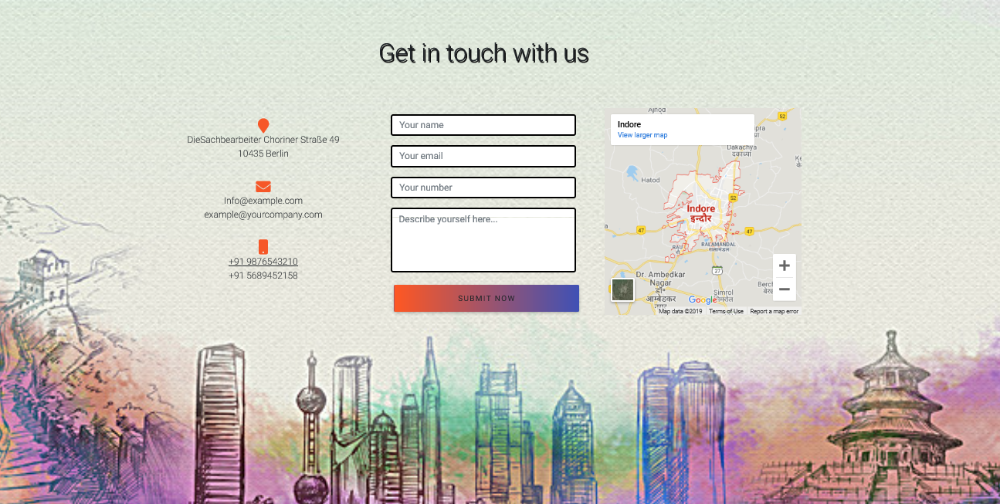



**ABOUT US PAGE:**

CLICK ON "ABOUT US" PAGE & PAGE WILL BE APPEAR……

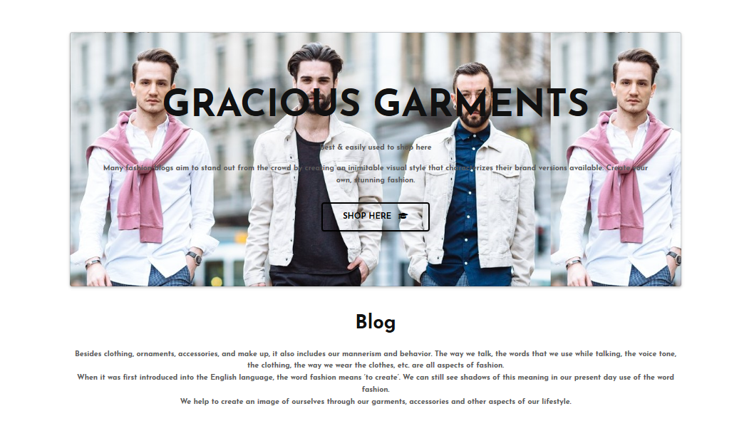





**LOG IN PAGE:**

CLICK ON "LOG IN" PAGE & PAGE WILL BE APPEAR……

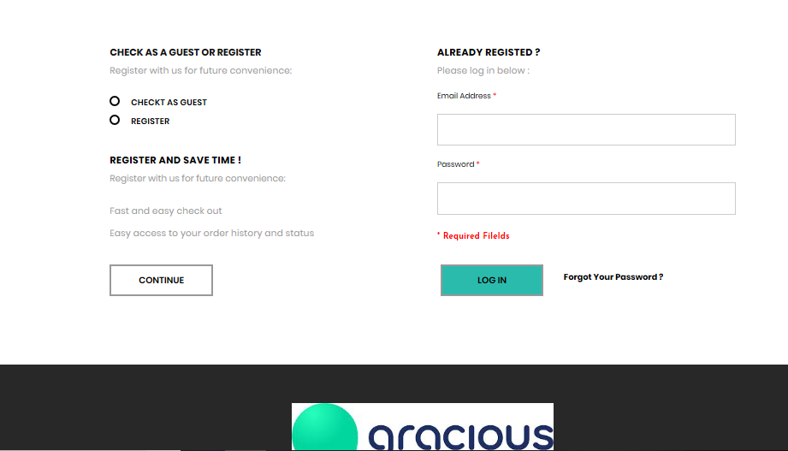



**REGISTER HERE PAGE:**

CLICK ON "REGISTER HERE" PAGE & PAGE WILL BE APPEAR……

